**Challenge Part 1**

**Project Challenge Brief: Data Preparation**

You are required to prepare data for Sales Analytics.

1. Create a New Notebook Called: SparkSalesAnalytics
2. Import the required Spark Libraries that can help you create a schema and assign datatypes
3. Create A Spark Session
4. Create A Heading: Data Preparation
5. Create A Schema based on the following blueprint:

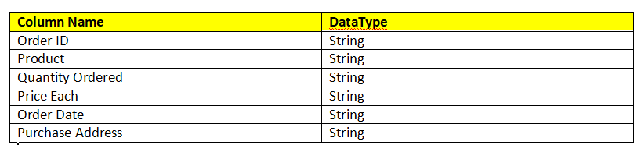

1. Download salesdata.zip into the data folder, and unzip/extract the contents into the directory path "data/salesdata"
2. Read the entire contents of the "data/salesdata" as a CSV into a Sales RAW Dataframe
3. Print out the first 10 records
4. Print out the Schema information